**The Levels of Ecological Organization:**

**Species:** is a unique organism with specific characteristics and members of a species can mate with each other and produce fertile offspring.

Examples: humans, dogs, cats, maple trees

**Population**: is a group of members of the same species that live in the same area.

Examples: a colony of ants, a herd of buffalo, a flock of geese, the residents of Kitchener

**Community**: is made up of populations of different species that live and interact in an area.

Examples: fish, turtles and snakes swimming in a pond, cats and dogs

**Ecosystem**: is the interaction of the community with the local abiotic factors.

Examples: coral reef, aquarium, backyard pond

**Biome**: Large geographical region that contains similar ecosystems due to a distinct climate and similar biotic and abiotic factors.

Examples: tundra, rainforest

**Biosphere**: part of our planet, including water, land and air, where life exists. All the biomes combine to form the biosphere.

**There are 3 main components of the biosphere:**

1. **Atmosphere:** layer of gases that surrounds the Earth
2. **Lithosphere:** the Earth’s solid outer layer
3. **Hydrosphere:** all the water on Earth

**Ecological Organization**

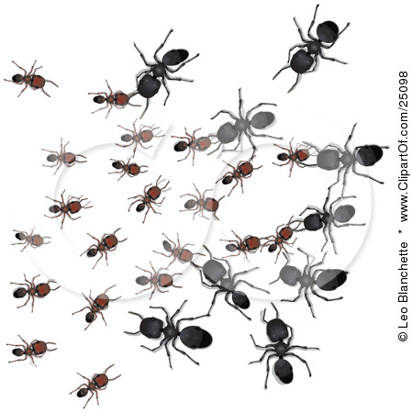

**Biosphere**

[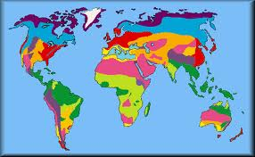](http://images.google.ca/imgres?imgurl=http://www.msss.sd8.bc.ca/SMALOFF/Africa%2520Biomes%2520-%2520WebQuest/A%2520WEBQUEST%2520ABOUT%2520BIOMES%2520IN%2520AFRICA_files/image001.gif&imgrefurl=http://www.msss.sd8.bc.ca/SMALOFF/Africa%2520Biomes%2520-%2520WebQuest/A%2520WEBQUEST%2520ABOUT%2520BIOMES%2520IN%2520AFRICA.htm&usg=__Op9niXH0jLg-IO-XJCx7SsOleNI=&h=289&w=468&sz=18&hl=en&start=12&tbnid=xGeOWSW_-baXNM:&tbnh=79&tbnw=128&prev=/images%3Fq%3Dgrassland%2Banimals%2Bbiome%26gbv%3D2%26hl%3Den)

**Biome**

[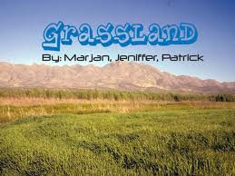](http://images.google.ca/imgres?imgurl=http://i32.tinypic.com/qx82gi.jpg&imgrefurl=http://biomef.wikispaces.com/Grassland&usg=__krCJcnDjY4JWlSLryHjVOGA640Q=&h=480&w=640&sz=110&hl=en&start=68&tbnid=m6GGOqlBYhTXzM:&tbnh=103&tbnw=137&prev=/images%3Fq%3Dgrassland%2Banimals%2Bbiome%26gbv%3D2%26ndsp%3D20%26hl%3Den%26sa%3DN%26start%3D60)

**Ecosystem**

[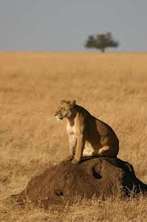](http://images.google.ca/imgres?imgurl=http://www.exfoleyation.co.uk/photography/Tanzania/images/09_%2520Lioness%2520on%2520anthill_JPG.jpg&imgrefurl=http://www.exfoleyation.co.uk/photography/Tanzania/index.htm&usg=__XeAuLomSbkNijgDlzdI4l0JJgYI=&h=1024&w=680&sz=67&hl=en&start=28&tbnid=zKpo2AEa58FDqM:&tbnh=150&tbnw=100&prev=/images%3Fq%3Danthill%26gbv%3D2%26ndsp%3D20%26hl%3Den%26sa%3DN%26start%3D20)

**Ecosystem**

[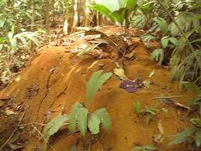](http://images.google.ca/imgres?imgurl=http://azoony.com/hattrips/sueno_azul_resort/giant_ant_hill.jpg&imgrefurl=http://azoony.com/hattrips/sueno_azul.html&usg=__CZRMtiHEn2285puvNtre9HE3JGM=&h=312&w=416&sz=54&hl=en&start=33&tbnid=qw0Ml-yjjcTH_M:&tbnh=94&tbnw=125&prev=/images%3Fq%3Danthill%26gbv%3D2%26ndsp%3D20%26hl%3Den%26sa%3DN%26start%3D20)

**Population**

**Species /individual**

