Powerful Pesticides: Affecting Us and Our Pests
Pesticide Use In Our Ecosystems
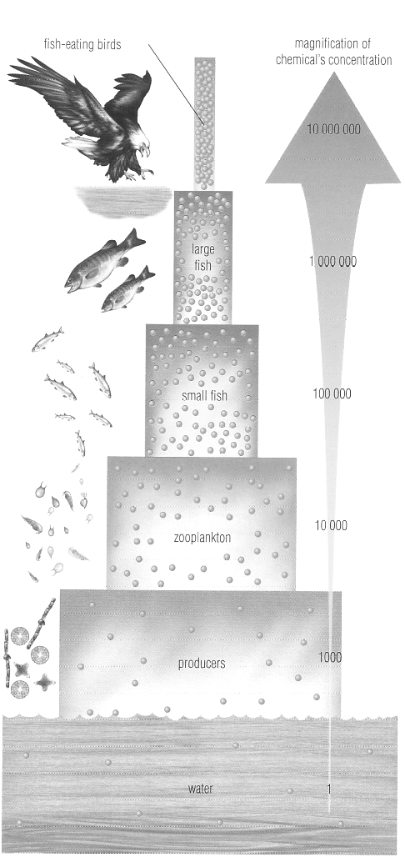
The risks of using powerful pesticides in ecosystems first became widely known during the 1950s and 1960s, when the toxic effects of the insecticide DDT were recorded. DDT was one of the first and most powerful pesticides developed. During World War II, it was used to control populations of insects (such as body lice and mosquitoes) that can transmit deadly diseases to people. As a result, the rate of death from malaria, bubonic plague, typhus, and yellow fever fell dramatically. DDT was also used widely on crops to control damage caused by insect pests.
About ten years after the first use of DDT, signs of trouble appeared. Dead birds, fish, frogs, and other animals were found in areas that had been heavily sprayed with DDT. The fat in their bodies contained high levels of the pesticide. Harmless or beneficial insects, such as butterflies and honeybees, also started to disappear from areas that had been sprayed.
Tests of soil and water showed that DDT remained in the environment for many years. For example, DDT was still found in the soil of some heavily sprayed orchards ten years after the spraying was stopped. DDT was also found in the bodies of many different organisms around the world where the insecticide had never been used. It also began showing up in the tissues of people.
An unexpected outcome of using DDT was its effect on populations of birds of prey. Numbers of hawks, eagles, and ospreys on farmlands across North America and Europe fell sharply during the 1950s and 1960s. Scientists discovered that DDT reduced the ability of these birds to produce normal eggshells. Affected birds laid eggs with thin shells that broke in the nest, so they were unable to produce the usual number of young. The adult birds accumulated DDT in their bodies from the fish they ate. The amount of DDT had accumulated in the bodies of organisms, moving from producers to primary consumers, to secondary consumers, and so on in a process called biomagnification. This process is illustrated in the diagram on the next page. The concentration of DDT in each organism is given in parts per million (ppm). One ppm is equivalent to 1mg/L.
DDT has not been banned worldwide, because in some cases, its societal benefits outweigh its environmental risks. DDT is used responsibly in mosquito-infested parts of Africa in homes and on mosquito nets. This saves millions of lives by combating an often lethal disease called malaria, which is carried by mosquitoes.
McGuinty Government Claims Pesticide Ban Protects Families and Children April 24, 2009
On Apr 22nd, 2009 (Earth Day), Ontario’s cosmetic pesticide ban came into effect. About 250 pesticide products are now banned for sale and more than 80 pesticide ingredients are banned for cosmetic uses. Consumers are now only able to purchase pesticides for public health or safety reasons such as fighting West Nile Virus, killing stinging insects like wasps, or to control poison ivy and other plants poisonous to the touch. Biopesticides and lower-risk pesticides to control weeds and pests will also be available.
“Earth Day this year is a particularly good day for the environment, and Ontario families, especially children. By banning the sale and use of cosmetic pesticides, we’ve eliminated the unnecessary risk posed by cosmetic pesticides and made Ontario a healthier place,” said John Gerretsen, Minister of the Environment
To help Ontario gardeners learn how to care for their lawns and gardens using greener alternatives, Communities in Bloom will be organizing seminars across the province, delivered by master gardeners or horticulturalists at community and garden centres. “We’re delighted to be involved in helping Ontarians achieve a pesticide-free landscape. Communities in Bloom is dedicated to promoting green spaces, especially in urban settings, and we’re proud that our efforts are helping the environment," said Lee Rozon, Executive Director, Communities in Bloom – Ontario.To support Ontario ’s emerging green economy, the Agricultural Adaptation Council will use a provincial investment of $480,000 to establish the Cosmetic Use Pesticides Research and Innovation Program. The program will encourage the development of lower-risk pesticides and other green alternatives. Ontario ’s ban is one of the toughest in the world. Quebec , PEI and Newfoundland and Labrador have imposed certain restrictions, while many American states have banned or restricted pesticides on or near child care facilities.

Questions: Use the diagram and your notes to answer the following questions.
- Why was DDT used in the early 1900s?
- How does DDT enter a food web? At what trophic level does DDT enter a food web?
- What is the relationship between the trophic level of an organism and the concentration of DDT in its body?
- How many times greater is the concentration of DDT in the large fish than in the seawater?
- How could an animal living hundreds of kilometers from an area sprayed with DDT get DDT into its body?
- DDT is stored in body fat and remains toxic for many years. Explain why these characteristics are undesirable in a pesticide. What characteristics would you want in a pesticide to make it less harmful to non-pest organisms?
- Explain why animals at the top of a food chain are particularly at risk from poisons in the environment.
- Why is DDT still used in some parts of the world today, even though its risks are well known?

